**PhET: Electric Charges and Fields** Name_________________________

Period ________________________

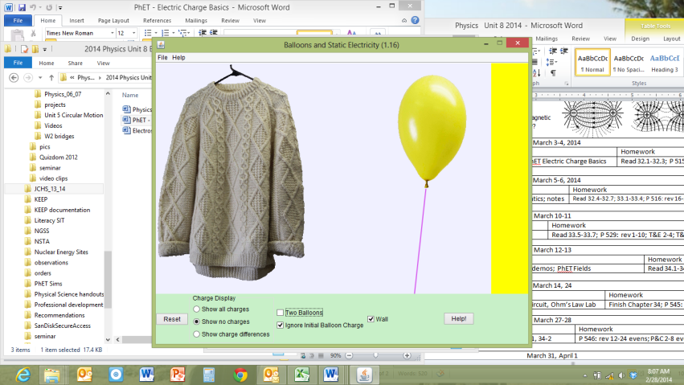Part I

1. Go to phet.colorado.edu
2. Open “Balloons”
3. Check “Show all Charges.” Nothing else should be checked.
4. Rub the balloon on the shirt
5. What overall charge does the balloon now have? ________________________________
6. What overall charge does the shirt now have? ___________________________________
7. What happens when you drag the balloon away from the shirt and let it go? ___________
8. Why? __________________________________________________________________
9. Reset
10. Check “Wall”
11. Rub the balloon on the shirt again.
12. What happens to the negative charges in the wall when you move the balloon near it? ________________________________________________________________________
13. What happens to the positive charges in the wall when you move the balloon near it? ________________________________________________________________________
14. Why don’t all the positive charges move toward the balloon? ______________________
15. Hold the balloon in between the wall and shirt and release it.
16. Why doesn’t the balloon just stay in the middle? ________________________________ ________________________________________________________________________

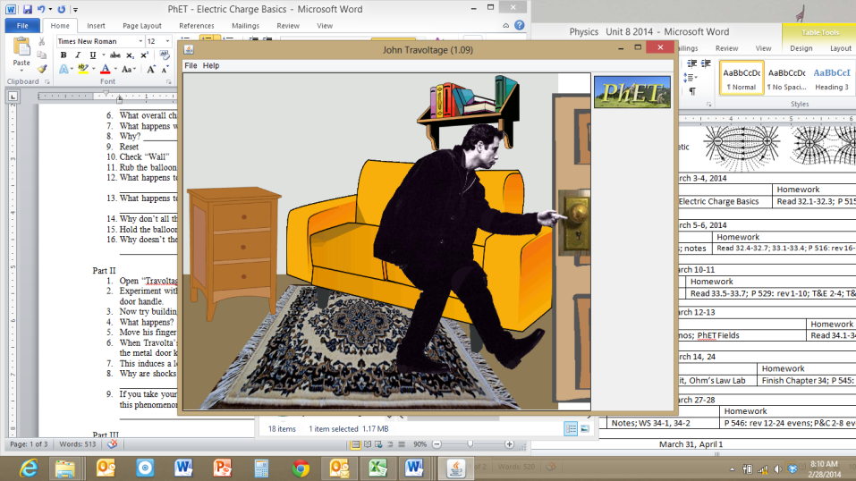Part II

1. Open “Travoltage”
2. Experiment with rubbing Travolta’s foot against the carpet and touching his finger to the door handle.
3. Now try building up charge while his finger is on the door.
4. What happens? ________________________________________________________
5. Move his finger away again and build up another charge
6. When Travolta’s finger is near the door knob, what happens to the electrons currently in the metal door knob? (Are they attracted or repelled?) ___________________________
7. This induces a local (+ or -) charge in the door knob.
8. Why are shocks worse when you touch conductors rather than insulators? ____________ ________________________________________________________________________
9. If you take your hat off on a dry winter day, sometimes your hair will stand up. Explain this phenomenon. _________________________________________________________ ________________________________________________________________________

Part III

1. Open “Electric Hockey”
2. The goal of this game is to get the black positive puck to go in the goal.
3. How can you set up just one negative charge to score a goal? (Remember to hit start) ________________________________________________________________________
4. Clear each time you try a new set up. Reset if you want to retry your current set up.
5. How can you set up just one positive charge to score a goal? ________________________________________________________________________
6. Change the mass and see what happens.
7. What happens when the mass is lighter? _______________________________________
8. Why does the mass affect the speed if it is not apart of the electric force equation? ________________________________________________________________________
9. Reset – Put one positive charge on the surface and one negative charge directly below it.
10. Check the “Field” box.
11. 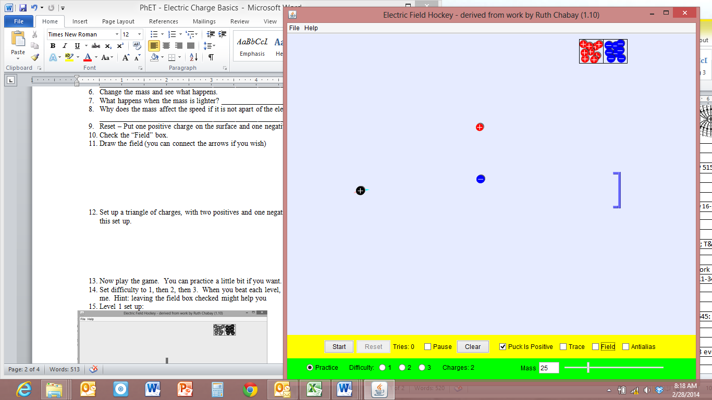Draw the field (you can connect the arrows if you wish) Two sample field lines are drawn for you.

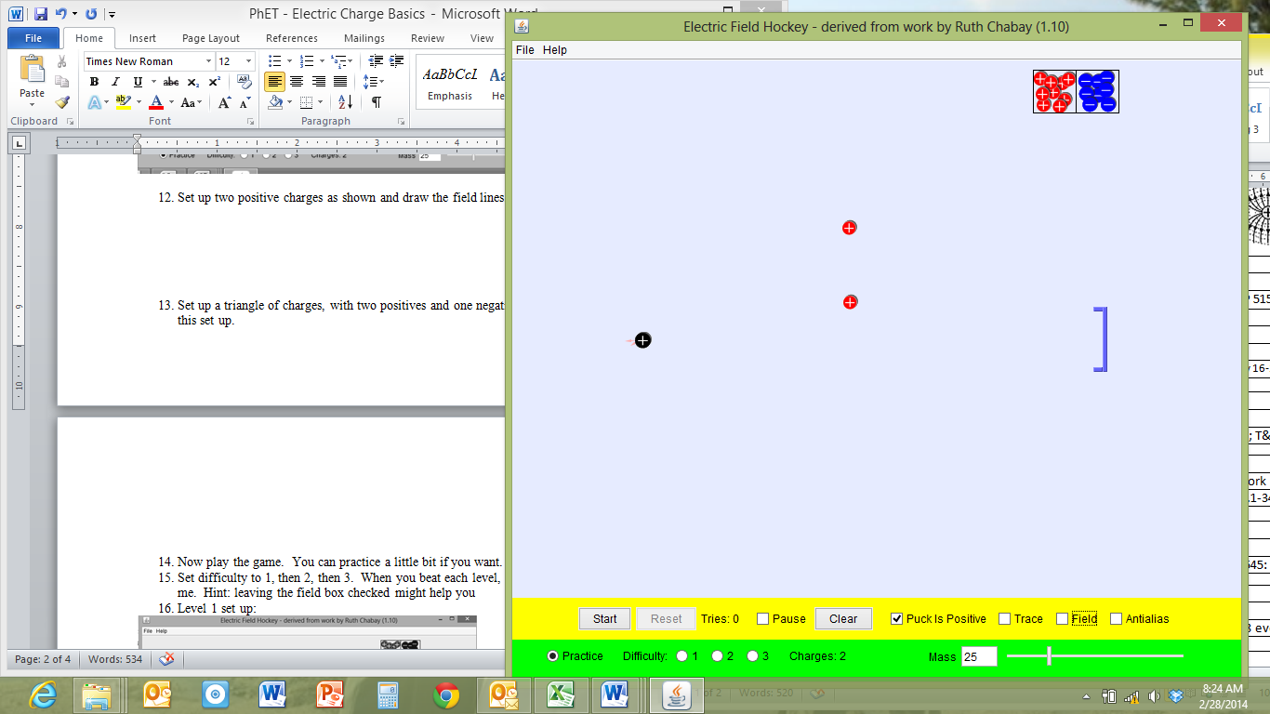

1. Set up two positive charges as shown and draw the field lines.
2. Set up a triangle of charges, with two positives and one negative. Draw the field lines for this set up.

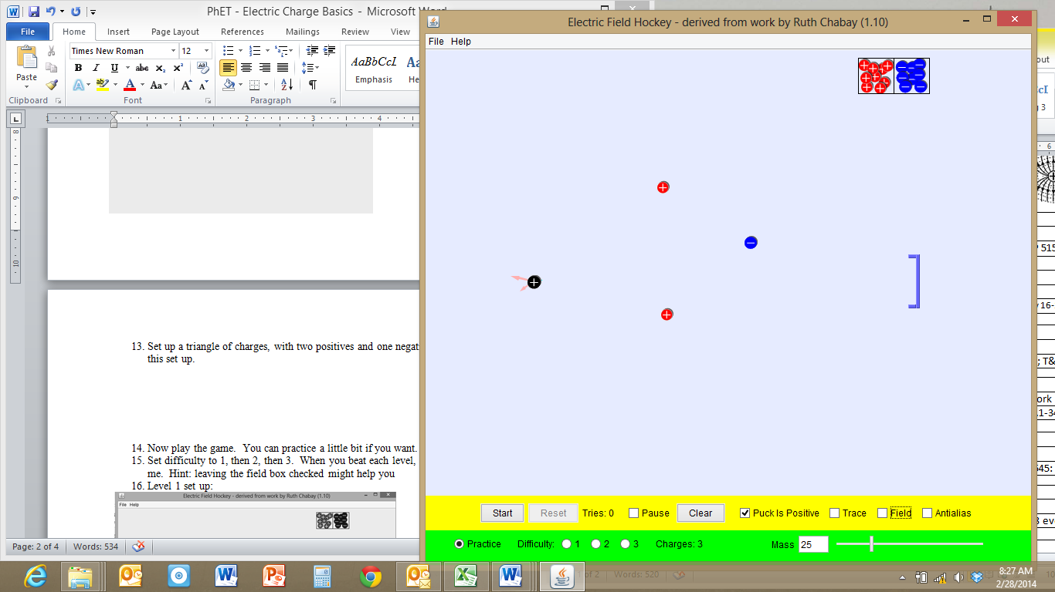

1. Now play the game.
2. Set difficulty to 1, then 2, then 3. When you beat each level, **draw your set up showing where you put the + and - charges**, and show me. Hint: leaving the field box checked might help you but you do not need to draw the field lines for your set up.
3. Level 1 set up:

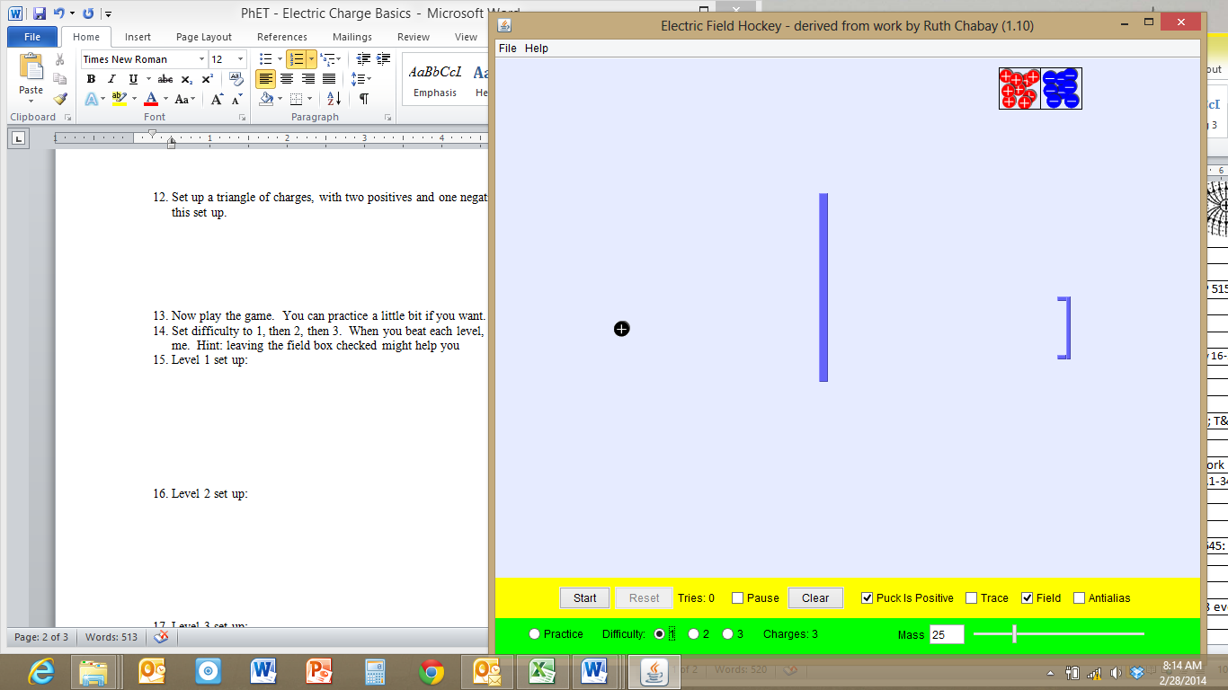

1. Level 2 set up:

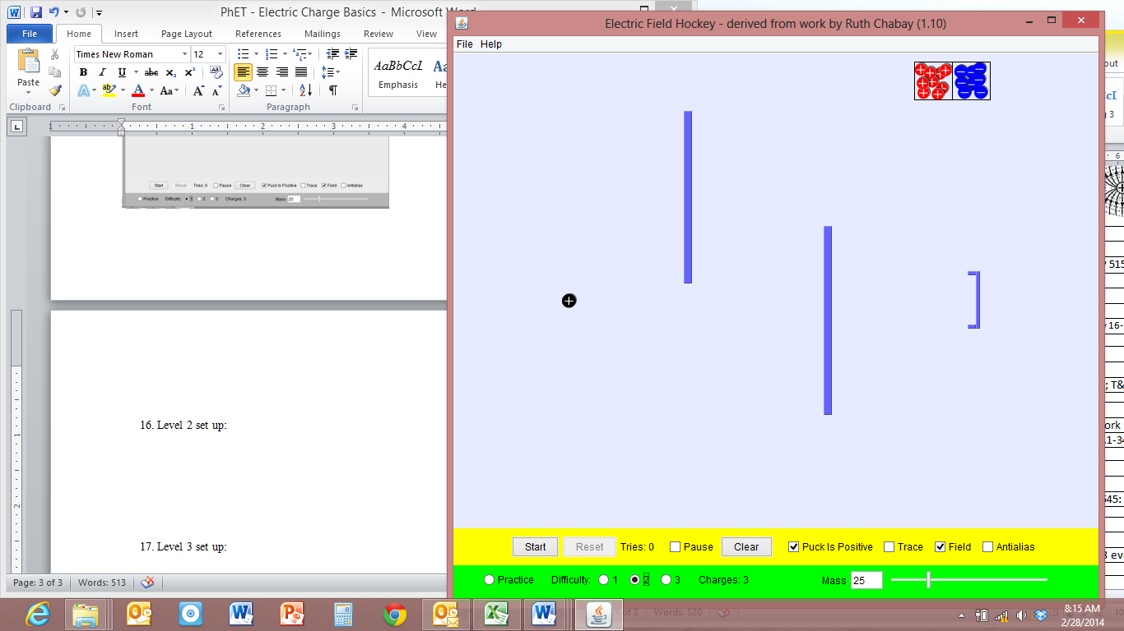

1. Level 3 set up:

